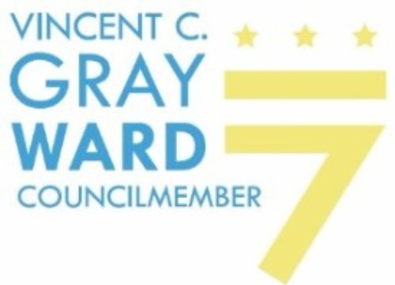

FOR IMMEDIATE RELEASE
April 28, 2021
Contact: Erik Salmi
202-445-0834
Council Special Committee on COVID-19 Pandemic Recovery Announces
Two Public Hearings

The Council’s Special Committee on the COVID-19 Pandemic Recovery has announced two public hearings in May focused on safety net protections and the future of public education as the District moves through the public health emergency (PHE).

The Special Committee is co-chaired by Ward 6 Councilmember Charles Allen and Ward 7 Councilmember Vincent C. Gray. The Special Committee was created this Council period by Chairman Mendelson with a goal of making recommendations for the District’s recovery from the global pandemic.

First, on May 21 the Special Committee will hold a hearing to examine the impact on residents as expanded safety net protections enabled by the Council’s emergency legislation, the Mayor, and the federal government during the public health emergency are phased out. This includes the evictions and utility shutoff moratoria, as well as expansions of TANF, SNAP, D.C. Healthcare Alliance, and Unemployment Insurance. As those safety net expansions wind down, the District needs to consider how to protect those who have relied on them.

Before the end of the moratoria, the District will need to have in place a plan to deal with the massive amount of unpaid back rent, which some estimate at between $13 and $52 billion nationally, to prevent mass evictions.

Second, on May 26 the Special Committee will hold a joint hearing focused on what the District’s public education system should look like coming out of the PHE. Most experts expect when student achievement can again be accurately measured, pre-existing gaps, largely along racial and economic lines, will have been exacerbated. Key questions face the future of our system: how do we ensure all students have access to high-speed internet at home and in school? How can we prepare school leaders and teachers to help students process any trauma from more than a year living remotely? Finally, the Committee will take up the issue on getting to and from school safely, as students resume their commutes in the fall.

###

